Kristina Artamonova
[Email address]
Abstract
Simulating a SOC environment on VM machines to show adaptation of AI security analysis tools.
Automating security log analysis with ai
Guide to simulate a SOC environment and implement AI tools for log analysis.

Table of Contents
Overview 2
Software used 2
Initial setup of machines 3
Splunk SOAR configuration for the Wazuh SIEM 4
Configuring the receiving port 4
Creating wazuh-alerts Splunk Indices 5
Wazuh Server configuration 5
Install the Splunk Universal Forwarder 6
Configuring Splunk Universal Forwarder 6
Configuring Splunk Web interface 8
Setting alert conditions 8
Configuring the alert Settings 8
YARA Integration 9
Detecting malware on Linux endpoints using YARA 9
Wazuh server configuration 12
Test the configuration 14
Visualize the alerts 14

Overview
This whitepaper document aims to show how to implement AI tooling into a SOAR (Security Orchestration, Automation, Response) platform. The platform are mostly used in SOCs (Security Operation Centres) and require a lot of analytical power to classify and nullify threats.
According to various research, the biggest shortcoming in a SOC environment is lack of automation, too many tools, alert fatigue and large time consumption on manual analysis. This document will walk through how to create a bare-bones SOC on a virtual machine and implement a level of automatic log analysis.
The installation procedures have been taken from publicly available documentation.
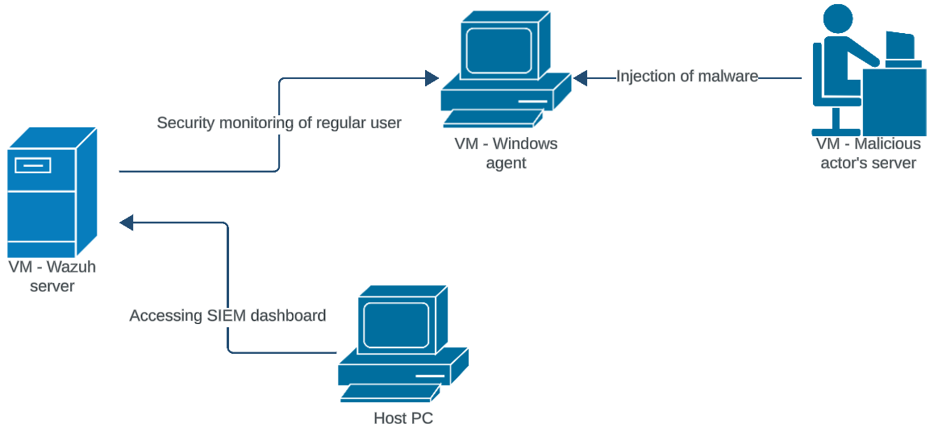
Figure 1. Use case of malicious actor attacking the client machine that has SIEM and SOAR installed. With the “Host PC” acting as the server or SOC administrator and the “Windows Agent” machine as the client machine under observation.

Software used
VMWare Workstation Pro – Industry standard desktop hypervisor, the container for the machines to run in.
Wazuh – Open source security platform. Endpoint and cloud security, threat intelligence an and security operation platform.
Splunk – AI-powered, a unified Security and Observability Platform.
Windows VM - Acting as the client machine.
YARA Rules – Pattern-matching swiss knife, a tool aimed to help malware researchers in identifying and classifying malware samples.

Initial setup of machines
We use the following infrastructure to demonstrate how we integrate Wazuh with Splunk using a Splunk Universal Forwarder.
- A CentOS 7 endpoint with the Wazuh 4.5.2 central components deployed. For installation, refer to the Wazuh installation options below.
- An Ubuntu 22.04 endpoint with Splunk Enterprise installed
Option 1: Installing Wazuh from scratch, follow the guide documentation provided here: https://documentation.wazuh.com/current/installation-guide/index.html
Option 2: Download a ready-to-use virtual machine image and install a Wazuh agent on the client as provided here: https://documentation.wazuh.com/current/deployment-options/index.html

Splunk SOAR configuration for the Wazuh SIEM

The Wazuh server integration using a Splunk Universal Forwarder operates by reading the /var/ossec/logs/alerts/alerts.json file data on the Wazuh server and forwarding them to Splunk. The Splunk indexer then creates indices for the alerts and displays them on Splunk Web, the user interface for Splunk Enterprise.
Before you configure the Splunk Universal Forwarder, it is essential to configure the Splunk indexer to accept the forwarded events coming from the Wazuh server.
Perform the following tasks on Splunk Web to:
- Configure a receiving port.
- Create the wazuh-alerts Splunk indices.

Configuring the receiving port

- Go to Settings > Forwarding and receiving.
- Under Receive data, click Add new.
- In the Listen on this port input box, enter 9997, and click Save. This is the Splunk receiving/indexing port
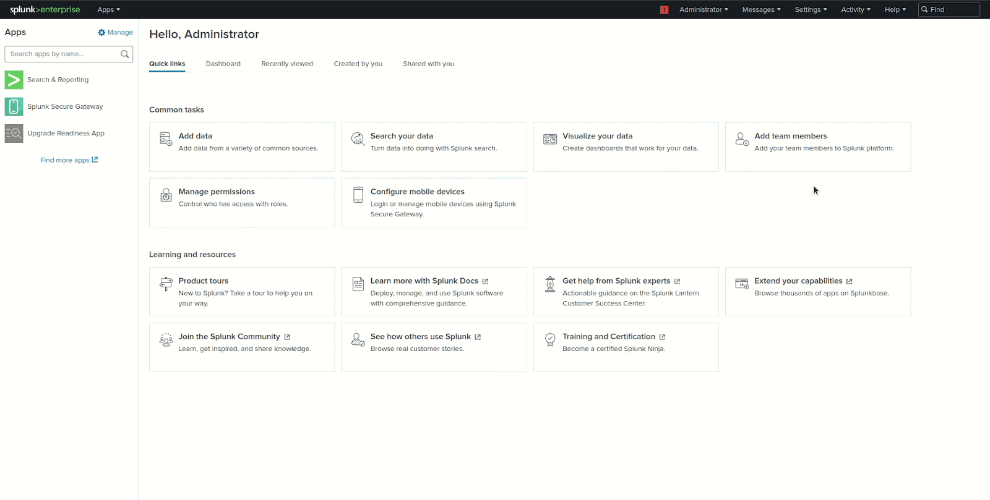
Figure 2. Configuring a receiving port on Splunk web.

Creating wazuh-alerts Splunk Indices

- Go to Settings > Indexes > New Index.
- Enter wazuh-alerts in the Index name field and click Save.
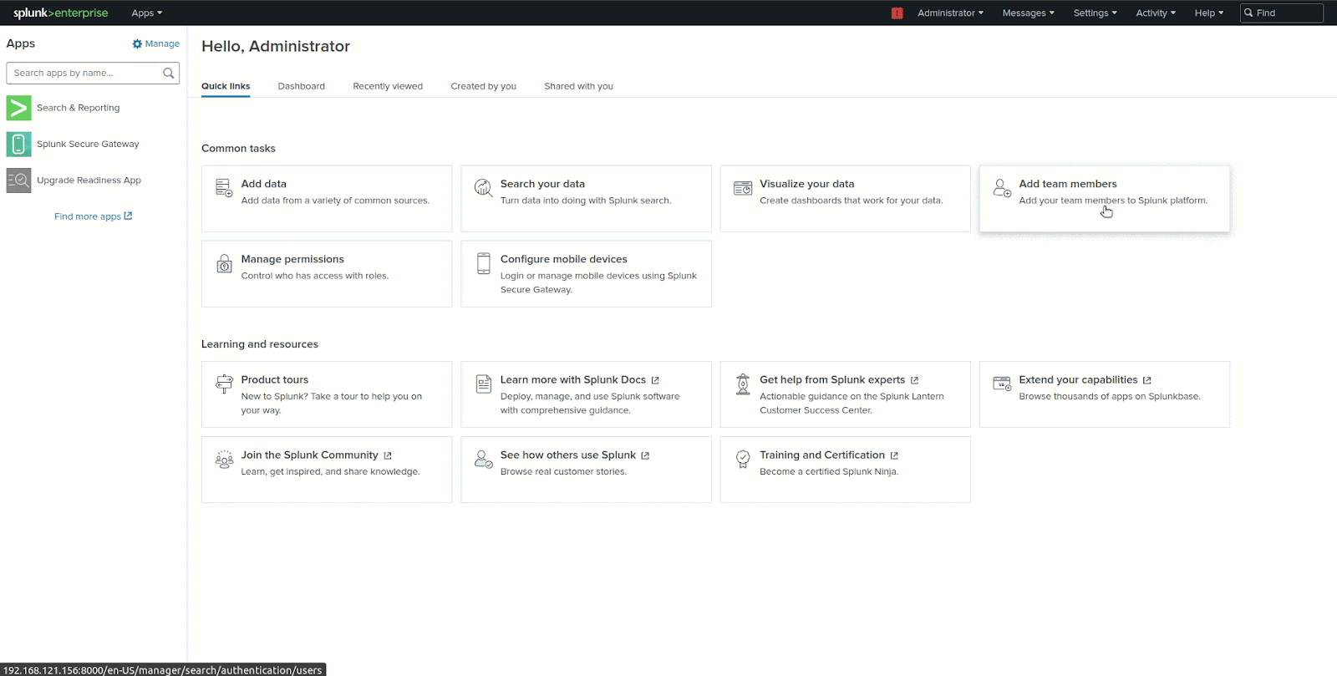
Figure 3. Configuring the wazuh-alerts indices on Splunk Web.

Wazuh Server configuration
This section focuses on installing and configuring the Splunk Universal Forwarder to read the /var/ossec/logs/alerts/alerts.json file data and forward them to the Splunk indexer.
On UNIX-based operating systems, the installation comes as a tar file or an installation package (.rpm, .deb, .pkg, etc.). The steps below describe how to install Splunk Universal Forwarder 9.1.1 on the Wazuh server.
Visit the Splunk Universal Forwarder documentation for the installation steps if you are using a different version or another Linux distribution here: https://docs.splunk.com/Documentation/Forwarder/9.1.1/Forwarder/Installanixuniversalforwarder#Install_the_universal_forwarder_on_Linux
Notes:
- Run all the commands below as the root user.
- Since we are using the root user for installation, you will receive the following warning after step 5: warning: user splunk does not exist - using root. Nonetheless, it won’t impact the installation process.
- Change the Splunk Universal Forwarder package name in the commands if you are using a version different from 9.1.1

Install the Splunk Universal Forwarder
- Download the Splunk Universal Forwarder package:
curl -o splunkforwarder.rpm "https://download.splunk.com/products/universalforwarder/releases/9.1.1/linux/splunkforwarder-9.1.1-64e843ea36b1.x86_64.rpm"
- Create the Splunk user and group. Splunk recommends that you implement the splunkfwd user from Splunk 9.1.
useradd -m splunkfwd
groupadd splunkfwd
- Create the $SPLUNK_HOME directory:
export SPLUNK_HOME="/opt/splunkforwarder"
mkdir $SPLUNK_HOME
- Move the splunkforwarder package in $SPLUNK_HOME:
mv splunkforwarder.rpm $SPLUNK_HOME
- Run the following command to install the package:
chmod 644 $SPLUNK_HOME/splunkforwarder.rpm
rpm -i $SPLUNK_HOME/splunkforwarder.rpm
- Change the ownership of the Splunk directory and everything under it to the Splunk user and group:
chown -R splunkfwd:splunkfwd $SPLUNK_HOME
Note: If you change users, you must run the command above again.
- Run the following command to start the Splunk Universal Forwarder and accept license utilization:
$SPLUNK_HOME/bin/splunk start --accept-license
Note: When you start the universal forwarder for the first time, it prompts you to create credentials for the Splunk administrative user. Type in the name and password you want to use for the administrative user. This is the user that you log into the universal forwarder with, not the user that you use to log into your system.

Configuring Splunk Universal Forwarder

Perform the steps below to configure the Splunk Universal Forwarder to ingest Wazuh JSON alerts and send them to the Splunk indexer.
- Create and set the following configuration in the /opt/splunkforwarder/etc/system/local/inputs.conf file. Replace <WAZUH_SERVER_HOST> with any name of your choice. This tags the logs with the host forwarding the logs in the Splunk indexer. This configures the Splunk forwarder to monitor the Wazuh /var/ossec/logs/alerts/alerts.json alerts file.
[monitor:///var/ossec/logs/alerts/alerts.json]
disabled = 0
host = <WAZUH_SERVER_HOST>
index = wazuh-alerts
sourcetype = wazuh-alerts
- Create and set the following configuration in the /opt/splunkforwarder/etc/system/local/props.conf file to parse the data forwarded to Splunk:
[wazuh-alerts]
DATETIME_CONFIG =
INDEXED_EXTRACTIONS = json
KV_MODE = none
NO_BINARY_CHECK = true
category = Application
disabled = false
pulldown_type = true
The DATETIME_CONFIG = field is left blank to use the default timestamp extraction logic of Splunk.
- Create and set the following configuration in the /opt/splunkforwarder/etc/system/local/outputs.conf file to define how to forward the alerts to Splunk. Replace <SPLUNK_INDEXER_ADDRESS> with the IP address of the Splunk server. For cloud instances, the Splunk indexer address is the cloud instance address.
defaultGroup = default-autolb-group
[tcpout:default-autolb-group]
server = <SPLUNK_INDEXER_ADDRESS>:9997
[tcpout-server://<SPLUNK_INDEXER_ADDRESS>:9997]
- Restart the Splunk Universal Forwarder to apply the configuration changes:
cd $SPLUNK_HOME/bin
./splunk restart
- Verify that your Splunk indexer is registered as a forward-server
$SPLUNK_HOME/bin/splunk list forward-server
Output
Warning: Attempting to revert the SPLUNK_HOME ownership
Warning: Executing "chown -R splunkfwd:splunkfwd /opt/splunkforwarder"
Active forwards:
<YOUR_SPLUNK_INDEXER_ADDRESS>:9997
Configured but inactive forwards:
None

Configuring Splunk Web interface
Perform the following tasks on Splunk Web to:
- Set alert conditions.
- Configure the alert settings.

Setting alert conditions
- Go to Search & Reporting.
- Enter the query below and run the search:
index="wazuh-alerts" location="/var/log/auth.log" "Failed password" | stats count by host, data.srcip | where count >= 5
- Click the Save As button above the search results and choose Alert.

Configuring the alert Settings
1. Enter a title and an optional description.
2. Specify the permissions.
3. Select the Real-time alert type. This type of alert triggers immediately when the condition is met.
4. Change the Expires setting if needed. This setting controls the lifespan of triggered alert records, which appear on the Triggered Alerts page.
5. Select the Per-Result trigger option. This option is selected by default.
6. Configure a trigger throttling period.
7. Select at least one alert action that occurs when the alert triggers. In our case, we choose the Add to Triggered Alerts option.
8. Assign an appropriate severity level to the alert. In our case, we selected High as severity.
9. Click Save.
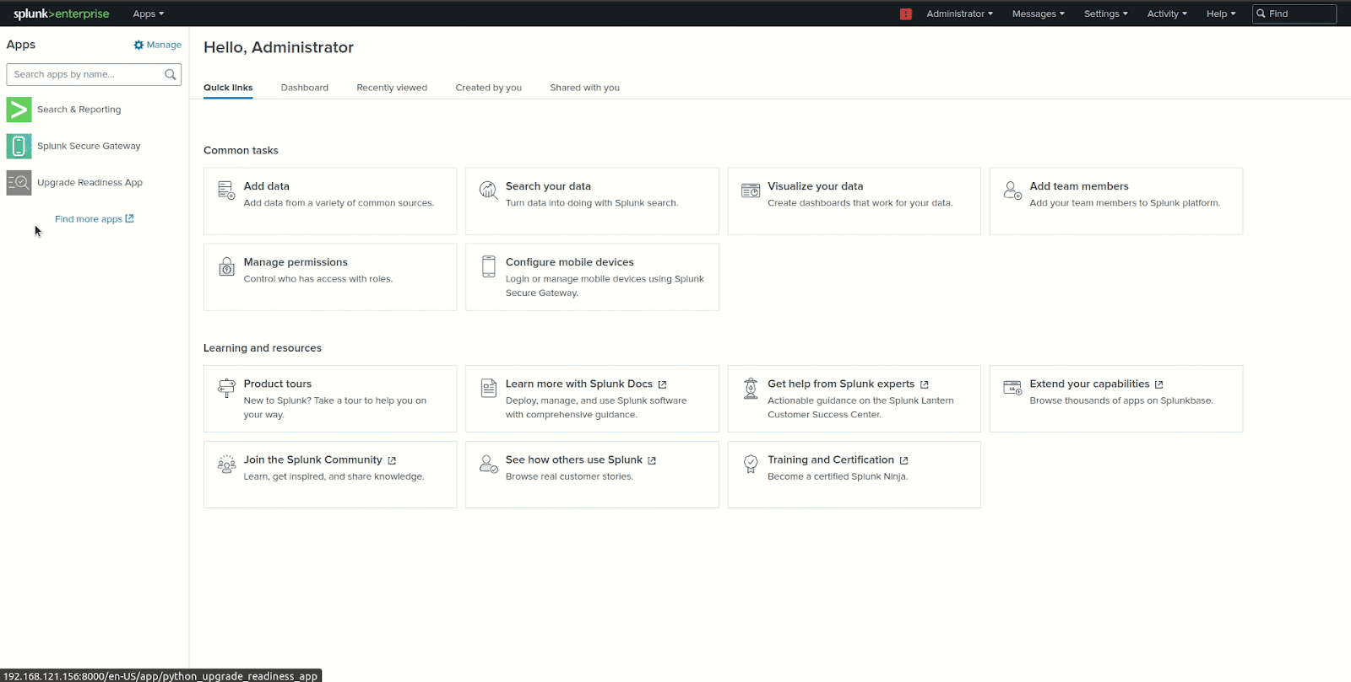
Figure 4. Scheduling alerts for brute force attempts in Splunk Web.

YARA Integration
YARA is a multi-platform program running on Windows, Linux and Mac OS X. You can find the latest release at https://github.com/VirusTotal/yara/releases.
You can combine the capabilities of the Wazuh FIM module with YARA to detect malware. YARA is an open source tool that identifies and classifies malware artifacts based on textual or binary patterns. These patterns are indicators found in malware samples and are defined in the YARA rules file. The YARA community updates the YARA rules file to include newly discovered malware signatures.
This technique detects malware in several stages and is achieved in the following way:
- The Wazuh FIM module scans monitored directories on endpoints to detect changes such as file creation and modifications.
- When FIM detects a change in the monitored directory or file, it triggers a YARA scan active response. The active response module automatically executes YARA using the yara.sh script. YARA then scans the file that triggered the FIM alert against its ruleset to determine whether it is malware.
- When the YARA rules match a file, the scan results are forwarded to the Wazuh manager for decoding, analysis and alerting. These scan results are not decoded out-of-the-box so you have to add the decoders to your Wazuh server.
- This implementation of YARA scans with the active response module concentrates the scans on new or recently modified files in monitored directories, thus optimizing resource consumption on the monitored endpoints.
The diagram below illustrates the flow of events between the different components.
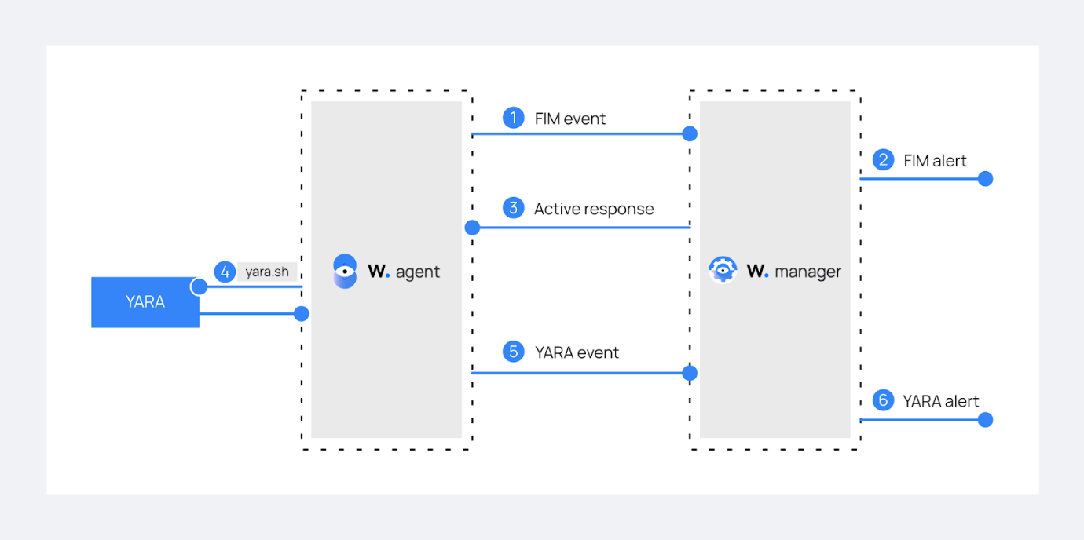

Detecting malware on Linux endpoints using YARA
Perform the following steps to configure YARA and the FIM module on the client machine.
- Download, compile, and install YARA:

sudo apt update
sudo apt install -y make gcc autoconf libtool libssl-dev pkg-config
sudo curl -LO https://github.com/VirusTotal/yara/archive/v4.2.3.tar.gz
sudo tar -xvzf v4.2.3.tar.gz -C /usr/local/bin/ && rm -f v4.2.3.tar.gz
cd /usr/local/bin/yara-4.2.3/
sudo ./bootstrap.sh && sudo ./configure && sudo make && sudo make install && sudo make check
- Test that YARA is running properly.
yara
Expected output:
yara: wrong number of arguments
Usage: yara [OPTION]... [NAMESPACE:]RULES_FILE... FILE | DIR | PID
Try `--help` for more options
If the error message below is displayed:
/usr/local/bin/yara: error while loading shared libraries: libyara.so.9: cannot open shared object file: No such file or directory.

This means that the loader doesn’t find the libyara library usually located in /usr/local/lib. Add the /usr/local/lib path to the /etc/ld.so.conf loader configuration file to solve this.
sudo su
echo "/usr/local/lib" >> /etc/ld.so.conf
ldconfig
Switch back to the previous user.
- Download YARA detection rules:
sudo mkdir -p /tmp/yara/rules
sudo curl 'https://valhalla.nextron-systems.com/api/v1/get' \
-H 'Accept: text/html,application/xhtml+xml,application/xml;q=0.9,*/*;q=0.8' \
-H 'Accept-Language: en-US,en;q=0.5' \
--compressed \
-H 'Referer: https://valhalla.nextron-systems.com/' \
-H 'Content-Type: application/x-www-form-urlencoded' \
-H 'DNT: 1' -H 'Connection: keep-alive' -H 'Upgrade-Insecure-Requests: 1' \
--data 'demo=demo&apikey=1111111111111111111111111111111111111111111111111111111111111111&format=text' \
-o /tmp/yara/rules/yara_rules.yar
- Create a /var/ossec/active-response/bin/yara.sh file and add the content below:
#!/bin/bash
# Wazuh - Yara active response
# Copyright (C) 2015-2022, Wazuh Inc.
#
# This program is free software; you can redistribute it
# and/or modify it under the terms of the GNU General Public
# License (version 2) as published by the FSF - Free Software
# Foundation.

#------------------------- Gather parameters -------------------------#

# Extra arguments
read INPUT_JSON
YARA_PATH=$(echo $INPUT_JSON | jq -r .parameters.extra_args[1])
YARA_RULES=$(echo $INPUT_JSON | jq -r .parameters.extra_args[3])
FILENAME=$(echo $INPUT_JSON | jq -r .parameters.alert.syscheck.path)

# Set LOG_FILE path
LOG_FILE="logs/active-responses.log"

size=0
actual_size=$(stat -c %s ${FILENAME})
while [ ${size} -ne ${actual_size} ]; do
sleep 1
size=${actual_size}
actual_size=$(stat -c %s ${FILENAME})
done

#----------------------- Analyze parameters -----------------------#

if [[ ! $YARA_PATH ]] || [[ ! $YARA_RULES ]]
then
echo "wazuh-yara: ERROR - Yara active response error. Yara path and rules parameters are mandatory." >> ${LOG_FILE}
exit 1
fi

#------------------------- Main workflow --------------------------#

# Execute Yara scan on the specified filename
yara_output="$("${YARA_PATH}"/yara -w -r "$YARA_RULES" "$FILENAME")"

if [[ $yara_output != "" ]]
then
# Iterate every detected rule and append it to the LOG_FILE
while read -r line; do
echo "wazuh-yara: INFO - Scan result: $line" >> ${LOG_FILE}
done <<< "$yara_output"
fi

exit 0;
This is the active response script that executes YARA scans when FIM detects changes in the monitored directory. The active response script receives these parameters from the generated FIM alerts:

- The file path contained in the alert that triggered the active response. The parameters.alert.syscheck.path key of the JSON alert holds the value of the file path. The path in this use case is /root/.
- YARA_PATH: This variable specifies the path to the directory where the YARA executable is located. We installed YARA in the /usr/local/bin directory as shown in step 2 above.
- YARA_RULES: This variable specifies the path to the file containing the YARA rules used for the scan.
This snippet of the script uses the parameters above to perform a YARA scan and appends the results to a log file called active-responses.log:
# Iterate every detected rule and append it to the LOG_FILE
while read -r line; do
echo "wazuh-yara: INFO - Scan result: $line" >> ${LOG_FILE}
done <<< "$yara_output"
For every line in the output of the YARA scan, the script appends an event to the active response log, /var/ossec/logs/active-responses.log, with the following format:
wazuh-yara: INFO - Scan result: yara_rule file_path
- Change the script ownership and permissions with the following commands:
sudo chmod 750 /var/ossec/active-response/bin/yara.sh
sudo chown root:wazuh /var/ossec/active-response/bin/yara.sh
- Install the jq utility to process the JSON data from the FIM alerts:
sudo apt install -y jq
- Add the following within the <syscheck> block of the Wazuh agent /var/ossec/etc/ossec.conf configuration file to monitor the /root/ directory:
<directories realtime="yes">/root/</directories>
- Restart the Wazuh agent to apply the configuration changes:
sudo systemctl restart wazuh-agent

Wazuh server configuration

The following steps are used to configure Wazuh FIM to alert file changes in a monitored directory on the endpoint. Then, to configure the active response module to trigger a YARA scan on detection of a new or modified file.
- Add the following custom decoders to the /var/ossec/etc/decoders/local_decoder.xml file. This extracts information from the YARA scan results:

<decoder name="yara_decoder">
<prematch>wazuh-yara:</prematch>
</decoder>

<decoder name="yara_decoder1">
<parent>yara_decoder</parent>
<regex>wazuh-yara: (\S+) - Scan result: (\S+) (\S+)</regex>
<order>log_type, yara_rule, yara_scanned_file</order>
</decoder>

- Add the following custom rules to the /var/ossec/etc/rules/local_rules.xml file:
<group name="syscheck,">
<rule id="100200" level="7">
<if_sid>550</if_sid>
<field name="file">/root/</field>
<description>File modified in /root directory.</description>
</rule>
<rule id="100201" level="7">
<if_sid>554</if_sid>
<field name="file">/root/</field>
<description>File added to /root directory.</description>
</rule>
</group>

<group name="yara,">
<rule id="108000" level="0">
<decoded_as>yara_decoder</decoded_as>
<description>Yara grouping rule</description>
</rule>
<rule id="108001" level="12">
<if_sid>108000</if_sid>
<match>wazuh-yara: INFO - Scan result: </match>
<description>File "$(yara_scanned_file)" is a positive match. Yara rule: $(yara_rule)</description>
</rule>
</group>

The rules group syscheck detects FIM events in the monitored directory. The rules group yara alerts when the YARA integration finds malware in the monitored endpoints directory. You can modify the rules to detect file creation and modification events from other directories.
- Configure the execution of the YARA script when files are added or modified to a monitored directory. Edit the Wazuh server /var/ossec/etc/ossec.conf configuration file and add the following:
<ossec_config>
<command>
<name>yara_linux</name>
<executable>yara.sh</executable>
<extra_args>-yara_path /usr/local/bin -yara_rules /tmp/yara/rules/yara_rules.yar</extra_args>
<timeout_allowed>no</timeout_allowed>
</command>

<active-response>
<command>yara_linux</command>
<location>local</location>
<rules_id>100200,100201</rules_id>
</active-response>
</ossec_config>

The <command> block describes information about the action to be executed on the Wazuh agent. It includes the following parameters:
- <name>: This uniquely identifies it as the yara_linux command.
- <executable>: This specifies the active response script or executable that must execute after a trigger. In this case, yara.sh.
- <extra_args>: This specifies where the YARA binary and rules are located.
- <timeout_allowed>: This specifies if the active response needs to undo an action after a specified period. It is set to no, which represents a stateless active response.
The <active-response> block defines the criteria used to execute a specific command:
- <command>: The previously identified yara_linux command.
- <location>: This specifies where the command executes. Using the local value means the command executes on the Wazuh agent that reported the event.
- <rules_id>: This represents the rule IDs that trigger the command:
- Rule 100200: File modified on the /root directory.
- Rule 100201: New file added to the /root directory.
- Restart the Wazuh manager to apply the configuration changes:
sudo systemctl restart wazuh-manager

Test the configuration

To test that everything is working correctly, we use the Mirai and Xbash malware samples.
Warning
These malicious files are dangerous so use them for testing purposes only. Do not install them in production environments.
- Download the malware samples and move them into the /root/ directory of the monitored endpoint.
curl https://wazuh-demo.s3-us-west-1.amazonaws.com/mirai --output ~/mirai
curl https://wazuh-demo.s3-us-west-1.amazonaws.com/xbash --output ~/Xbash
sudo mv ~/mirai /root/
sudo mv ~/Xbash /root/

Visualize the alerts

You can see these alerts on the Wazuh dashboard. To do this, go to the Security events tab of the Wazuh dashboard to view the alerts.
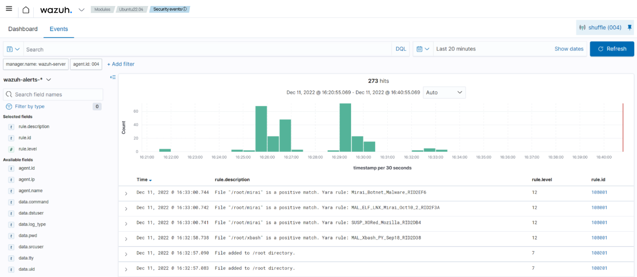
Figure 5. Screenshot of the filtered alerts performed by YARA
To integrate the malware detection on Windows machines, follow the instructions here: https://documentation.wazuh.com/current/user-manual/capabilities/malware-detection/fim-yara.html

